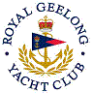 | Royal Geelong Yacht Club Inc.  Est 1859
Trophy Deed of Gift.

Trophy: | Mistral Bowl
Presented by: | Mauice C. Down
Date: | 1968
For: | Event Nominated Annually
Remarks / Revisions | Appreciation of Club Hospitality.
Click here for a List of Recipients

